

# External Documentation for Assignment 4

Contents

External Documentation for Assignment 2 1

Description 2

Version History 3

Detailed Game Description 5

Game Play Mechanics 5

Controls 5

Scoring 5

Interface Sketch 6

Screen Descriptions 7

Art Assets 7

## Description

The game is a side-scroller where you are a car that has to collect money and avoid other cars on the road.

## Version History

I pulled the version history from github using the shell command:

git log --pretty=format:"%h - %an, %ad : %s"

You can also find it at: <https://github.com/graydon-armstrong/Assignment2/commits/master>

If you want better readability.

bcb9791 - Graydon Armstrong, Fri Jun 7 14:14:46 2013 -0400 : Made it so you couldn't play with no money

2341b8c - Graydon Armstrong, Fri Jun 7 13:21:21 2013 -0400 : Changed winning multipliers

507421e - Graydon Armstrong, Fri Jun 7 13:16:13 2013 -0400 : Changed winning multipliers

cbc3a9d - Graydon Armstrong, Fri Jun 7 13:15:12 2013 -0400 : Rearranged Images and changed how jackpots work

97a01d0 - Graydon Armstrong, Fri Jun 7 13:09:04 2013 -0400 : Made the game harder to win by changing some of the chances to get certain reels

9fa870a - Graydon Armstrong, Fri Jun 7 12:29:52 2013 -0400 : Fixed a bug with the jackpot

abd30bb - Graydon Armstrong, Fri Jun 7 12:26:35 2013 -0400 : Added a method to make certain reel choices show up more often

a7b258d - Graydon Armstrong, Fri Jun 7 12:18:12 2013 -0400 : Finished calculating bets and updating various variables and labels accordingly

85a55ab - Graydon Armstrong, Fri Jun 7 11:57:42 2013 -0400 : Started calculating bets and added reset button functionality

4e7e413 - Graydon Armstrong, Fri Jun 7 11:36:03 2013 -0400 : Added variables to represent the bet, money and jackpot of the game

2c0b7a4 - Graydon Armstrong, Fri Jun 7 11:31:40 2013 -0400 : Changing to version 3 to add functionality

36a8a4f - Graydon Armstrong, Fri Jun 7 10:25:38 2013 -0400 : Added functionality for quit button

eb74b9e - Graydon Armstrong, Fri Jun 7 10:23:25 2013 -0400 : Added reset and quit buttons

69d418e - Graydon Armstrong, Fri Jun 7 10:09:38 2013 -0400 : Added functionality for clicking on the bet buttons

b9ab094 - Graydon Armstrong, Fri Jun 7 10:03:12 2013 -0400 : Added bet and jackpot labels. Also added labels for the bet change buttons

fcdab2a - Graydon Armstrong, Fri Jun 7 09:55:10 2013 -0400 : Added a few comments and reformatted code readability

552a8b6 - Graydon Armstrong, Fri Jun 7 09:53:26 2013 -0400 : Fixed error

12d6251 - Graydon Armstrong, Fri Jun 7 09:51:42 2013 -0400 : Adding Bet Buttons

62680d8 - Graydon Armstrong, Fri Jun 7 09:42:15 2013 -0400 : Changed position of reels and added a label for the spin button

c761e1d - Graydon Armstrong, Fri Jun 7 09:37:15 2013 -0400 : Changed reversion history to match new version

47bc21e - Graydon Armstrong, Fri Jun 7 09:36:28 2013 -0400 : Started version 2

7e39378 - Graydon Armstrong, Fri Jun 7 09:34:49 2013 -0400 : Added images for the reels

fa5e028 - Graydon Armstrong, Fri Jun 7 01:43:15 2013 -0400 : Refactored the mouseWithin function to get the mouses co-ordinates inside itself

92c3cf8 - Graydon Armstrong, Fri Jun 7 01:41:39 2013 -0400 : Made a method to see the mouse is within the object

b999e70 - Graydon Armstrong, Fri Jun 7 01:36:36 2013 -0400 : Tested out Adding a label on the screen

0cbae92 - Graydon Armstrong, Fri Jun 7 01:27:51 2013 -0400 : Fixed bug that would leave the spin button in a clicked state graphically

6040b25 - Graydon Armstrong, Fri Jun 7 01:19:01 2013 -0400 : Added Basic spinning on a basic GUI

7ff92e8 - Graydon Armstrong, Fri Jun 7 01:10:13 2013 -0400 : A placeholder for spinning the reels later

c66c999 - Graydon Armstrong, Fri Jun 7 01:09:40 2013 -0400 : Added Spinbutton properties and renamed the boxs to reels

7113965 - Graydon Armstrong, Fri Jun 7 00:58:29 2013 -0400 : Added temp spin button on screen

e14ed60 - Graydon Armstrong, Fri Jun 7 00:52:43 2013 -0400 : Added 3 boxes that reprisent the reels

794fd40 - Graydon Armstrong, Fri Jun 7 00:37:10 2013 -0400 : Placed a box on screen that you can move position by clicking

07f930b - Graydon Armstrong, Fri Jun 7 00:29:02 2013 -0400 : Put the game loop in a main method

0aed6e3 - Graydon Armstrong, Fri Jun 7 00:28:12 2013 -0400 : Added a main pygame game loop

cb7e061 - Graydon Armstrong, Thu Jun 6 01:22:33 2013 -0400 : Initial Commit for the start of the assignment

## Detailed Game Description

The game is a slot machine where the user can bet money in increments of 1, 5, and 10 to try and win money. If the player has enough money to bet he can spin the machine which randomly chooses out of seven options. The options are a blank and six different shapes including a: bar, bell, cherry, orange, grape, and a seven. The player loses their spin if a blank shows up on any of the three reels. If there are no blanks when the reels are spun the money won is the money bet times the multiplier for each shape. The player also wins the jackpot if the shapes are three of the same shape out of the cherry, bell or sevens. The player cannot spin if he doesn’t have enough money left. The player can reset the game and quit if they want as well.

### Game Play Mechanics

The player has the choice between three different bet increments and have a higher chance of winning more with the higher increments.

### Controls

The user uses the mouse to click on the available buttons on the screen. You can change you bet with the three options, spin the reels to try and win, reset the game, or quit.

### Scoring

The user wins when he gets three images that aren’t blanks. Here are the score multipliers for each:

Blank - 0

Bar – 1.1

Grape -1.25

Orange – 1.5

Cherry – 2.0

Bell – 2.8

Seven – 5.0

## Interface Sketch

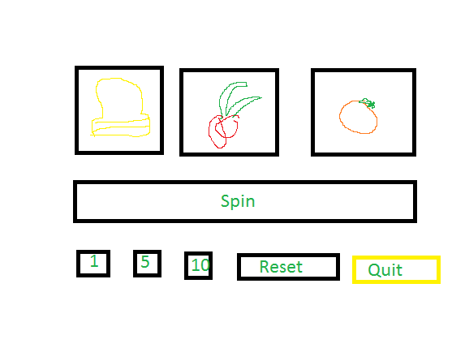

## Screen Descriptions

## 

## Art Assets

